United States Medicare Data Visualization by Hospital Provider : Exploring overall health care by Spending Data
Introduction :
Medicare is the federal health insurance program for people who are 65 or older, certain younger people with disabilities and people with End-Stage Renal Disease (permanent kidney failure requiring dialysis or a transplant, sometimes called ESRD). Having a clear visualization of Medicare data is relevant in identifying the available providers and help policy makers in decision making .
This paper is aimed at providing an interactive app showing overall Status of Health Care by Hospital provider in a Dashboard. Using this dashboard, we can get overview of total number of medications prescribed in each state, most prescribed medications in each state, average cost of inpatient and outpatient treatment, common inpatient diagnostic conditions in USA hospitals etc.
Important variable are selected to show an overall health care status by period and claim type in the dashboard.

Relevance of this Study to Current Health System

United Sates USA The Patient Protection and Affordable Care Act (ACA) since 2010. The Patient Protection and Affordable Care Act of 2010 has significantly changed health care in the United States. It made insurance available to between 32 million and 50 million more Americans or 95% of the legal population.
Getting an overview in the healthcare data in an interactive dashboard will help us to understand how the policy aligns with the current situation of healthcare system and policy makers can take better decision about the old ACA policy and weather any new policy needed or not. The dashboard will enable us to observe Medicaid and essential health benefits which is a key part of the current policy. The convergence of big data, analytics, and transparency will bring a sea change to the world of health care by necessitating new ways to communicate information to end users, such as payers, providers, researchers, and consumers. If health care payers can analyze large amounts of claims data effectively, they can improve service and care delivery for their recipients.

Overview of Medicare Spending
According to the Center of Medicare and Mediaid Services, Medicare plays a major role in the health care system, accounting for 20 percent of total national health spending in 2017, 30 percent of spending on retail sales of prescription drugs, 25 percent of spending on hospital care, and 23 percent of spending on physician services. In 2018, Medicare spending (net of income from premiums and other offsetting receipts) totaled $605 billion, accounting for 15 percent of the federal budget.
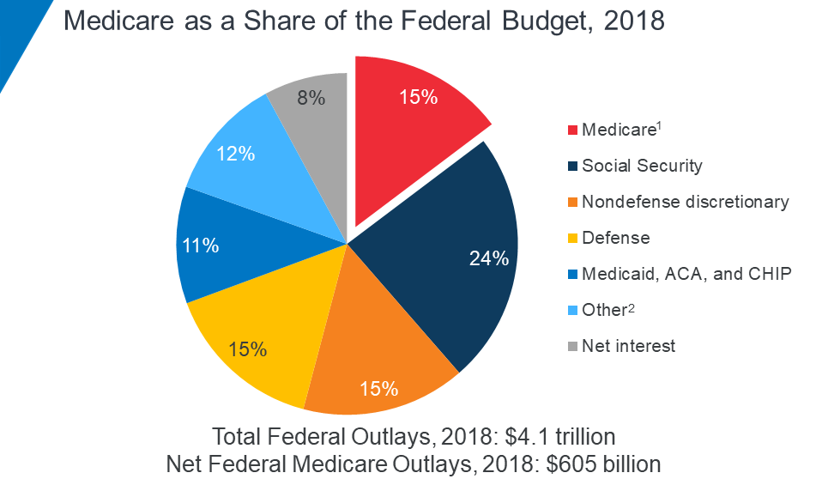
Pie Chart showing Medicare as s share of the Federal Budget , 2018 sourced from https://www.kff.org/medicare/issue-brief/the-facts-on-medicare-spending-and-financing/

According to a study conducted by Kaiser Family Foundation (KFF), while Medicare spending is expected to continue to grow more slowly in the future compared to long-term historical trends, Medicare’s actuaries project that future spending growth will increase at a faster rate than in recent years, in part due to growing enrollment in Medicare related to the aging of the population, increased use of services and intensity of care, and rising health care prices.
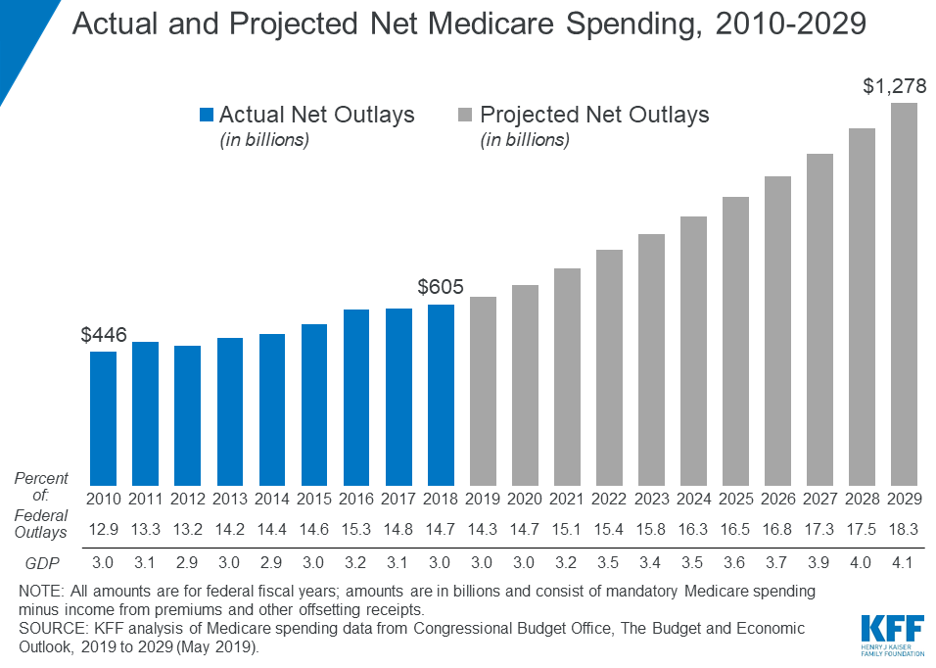

Data Source and Description
Medical information per beneficiary data and data description was obtained from https://healthdata.gov/dataset/medicare-hospital-spending-claim. The data displayed here shows average spending levels during hospitals’ Medicare Spending per Beneficiary (MSPB) episodes. An MSPB episode includes all Medicare Part A and Part B claims paid during the period from 3 days prior to a hospital admission through 30 days after discharge. These average Medicare payment amounts have been price-standardized to remove the effect of geographic payment differences and add-on payments for indirect medical education (IME) and disproportionate share hospitals (DSH).
Glimpse of the Data set :
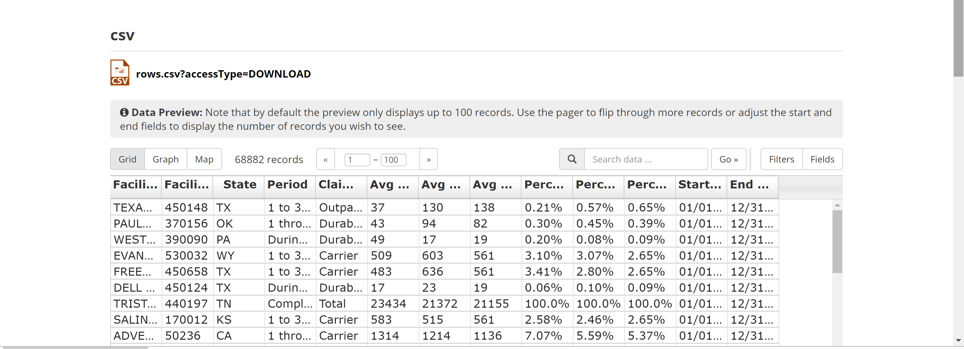
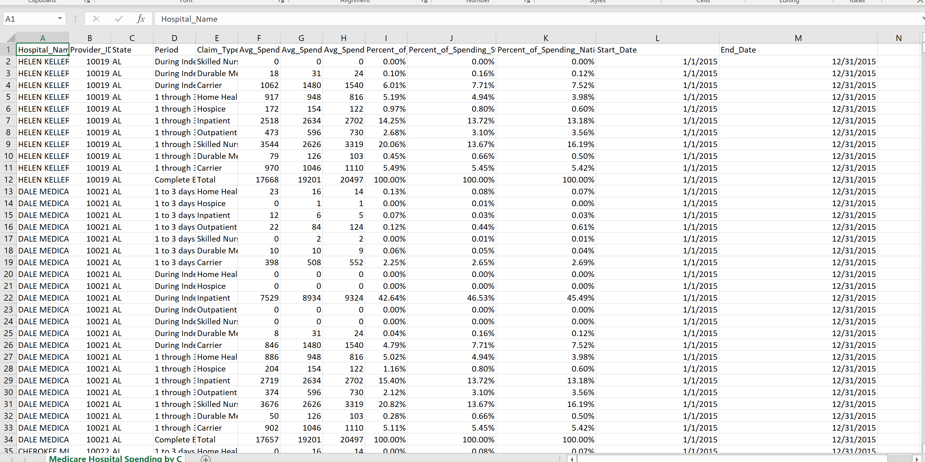

Interactive Visualization of the Data through Apps and its Purpose ***
The aim of this dashboard is to explore the differences on average spending across providers by period and claim type within states. The full interactive app can be accessed from https://yohannesdeboch.shinyapps.io/data608finalprojectbyyohannesd/.
The average spending was compared across states in the following scatter plot helps to visualize Medicare average spending per episode among different providers. You can explore average spending within each state for a given period and type of claim by selecting the state from the drop-down box, and period and claim type from the radio buttons.
Summary statistics of average spending for a given selection is provided on the top of the application, followed by scatter plot of average spending. Provider with highest average spending are listed under the scatter plot. The app will enable us to see the name of provider and the average spending by hovering the cursor on each observation.
Some Glimpse of the Interactive visualization is provided as follows :
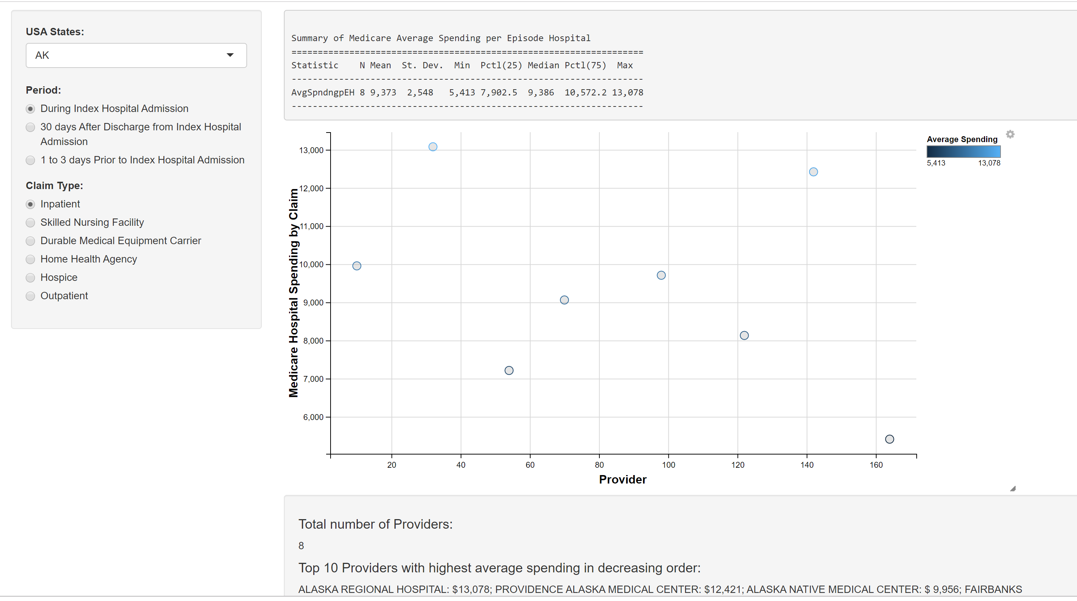

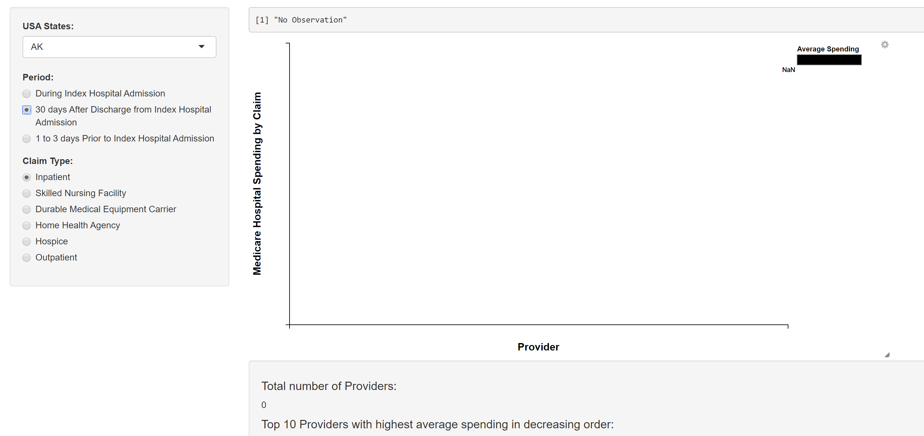

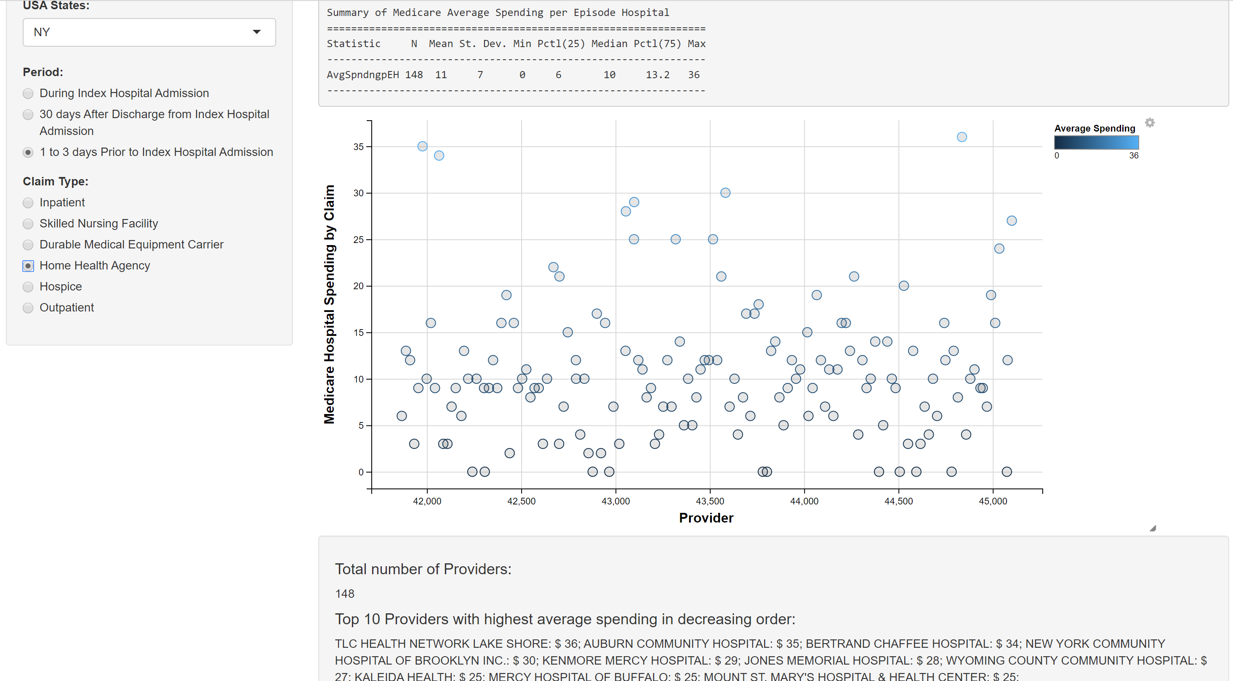
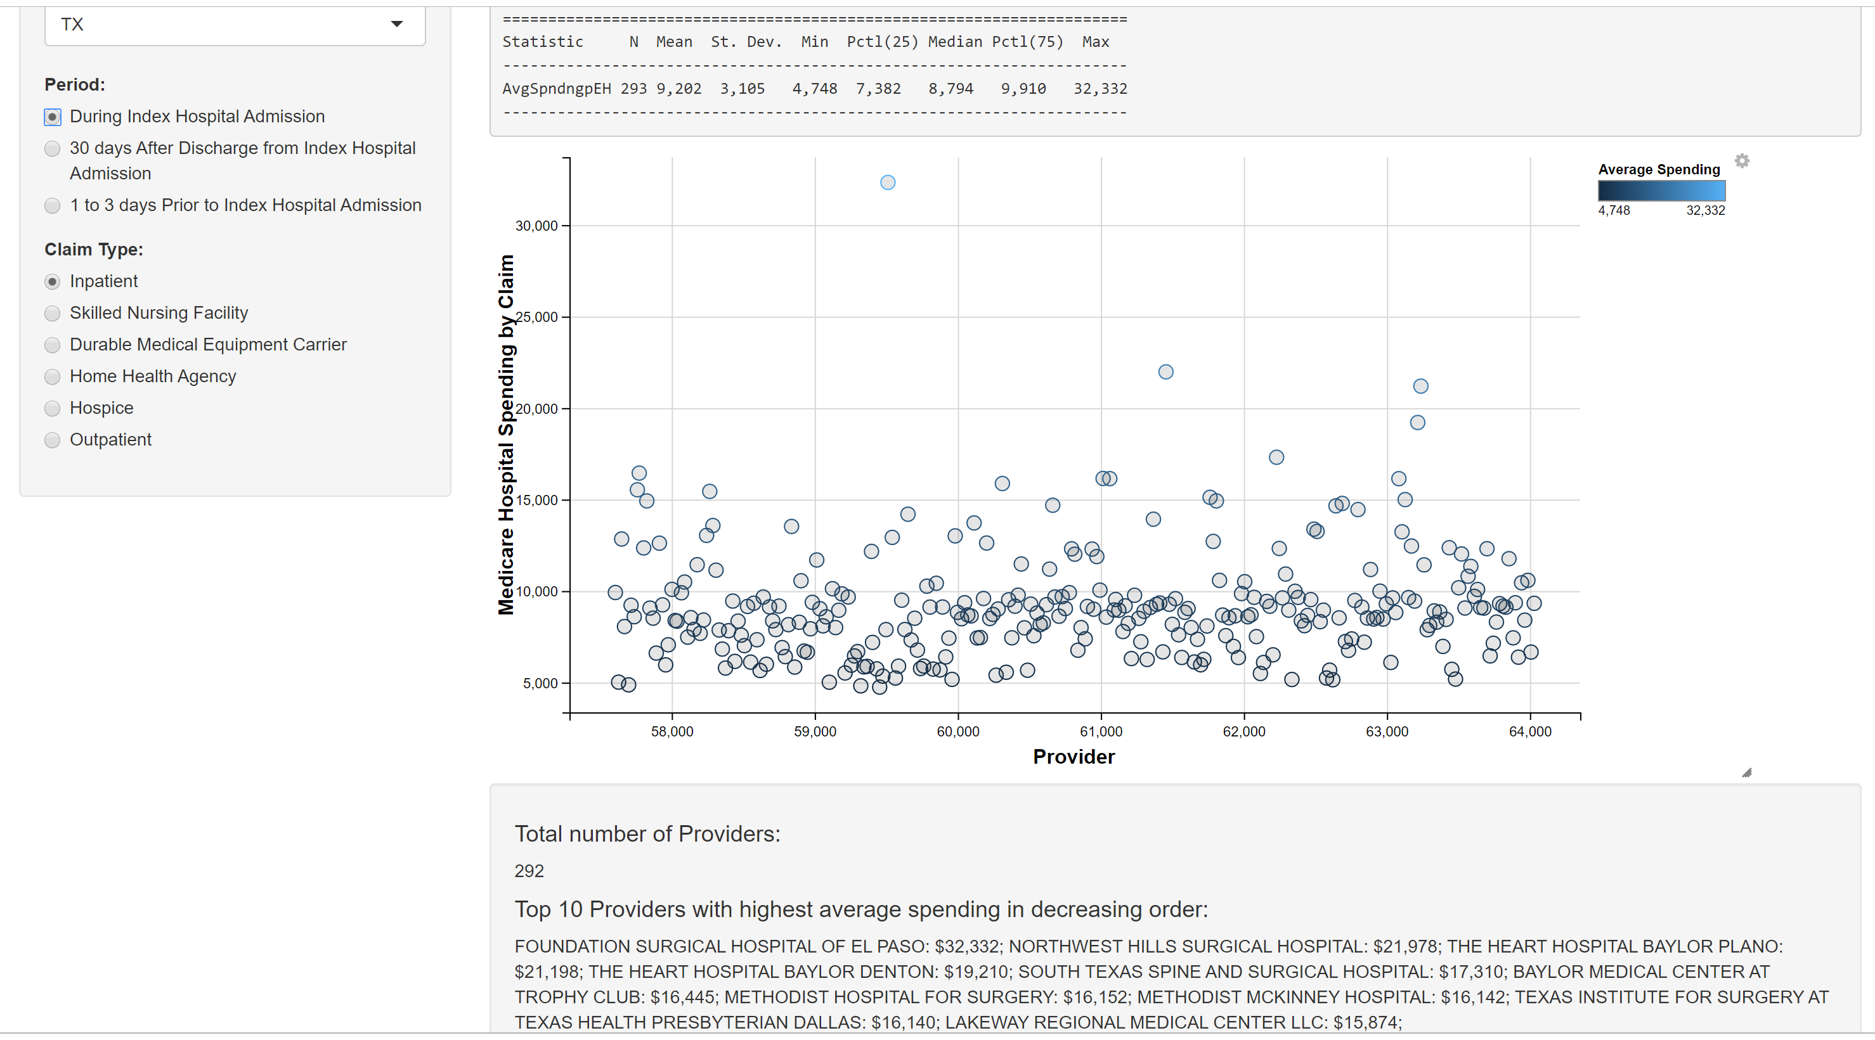
In summary the top ten highest average spending was for inpatient claims during index hospital admission in the state of Texas (3 providers), Ohio, Nebraska, Indiana, Kansas (each 1 provider) and Oklahoma (2 provider).
*** The full interactive app is available on :
https://yohannesdeboch.shinyapps.io/data608finalprojectbyyohannesd/

https://www.medicareinteractive.org/get-answers/medicare-basics/medicare-overview/introduction-to-medicare.
https://www.rand.org/health-care/key-topics/health-policy.html.
https://www.thebalance.com/2010-patient-protection-affordable-care-act-3306063.
https://www.cms.gov/Research-Statistics-Data-and-Systems/Statistics-Trends-and-Reports/NationalHealthExpendData/NationalHealthAccountsHistorical.
https://www.kff.org/medicare/issue-brief/the-facts-on-medicare-spending-and-financing/.

